TEMASEK POLYTECHNIC
SCHOOL OF INFORMATICS & IT

Logic and Mathematics
Tutorial 8 (Topic: Sequence and Recursion)

Sequence
1. Find the first 3 terms of the sequence

2. Find an explicit formula for the following sequences with these initial terms:

(a) 2, 4, 8, 16, 32, 64
(b)

Summations and Products

3. Evaluate the following:
(a) (b)

4. Write the summation or product in expanded form:

5. Write the following using summation or product notation:
(4-3) +(5-3) +(6-3) +…+(p-3)

6. Make the change in variables j = k - 2 for

Show all your working.

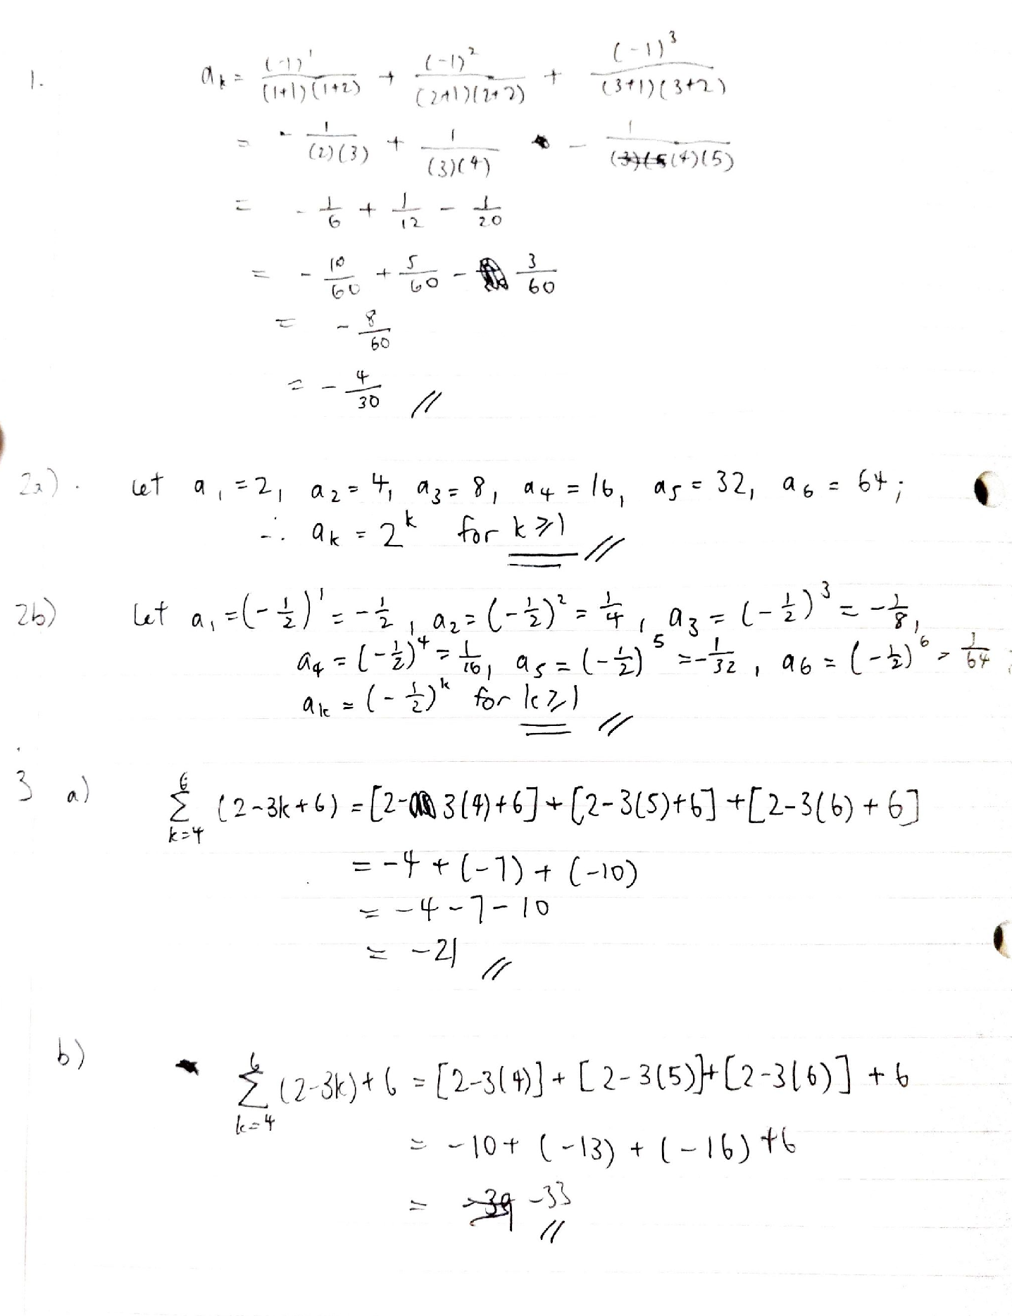

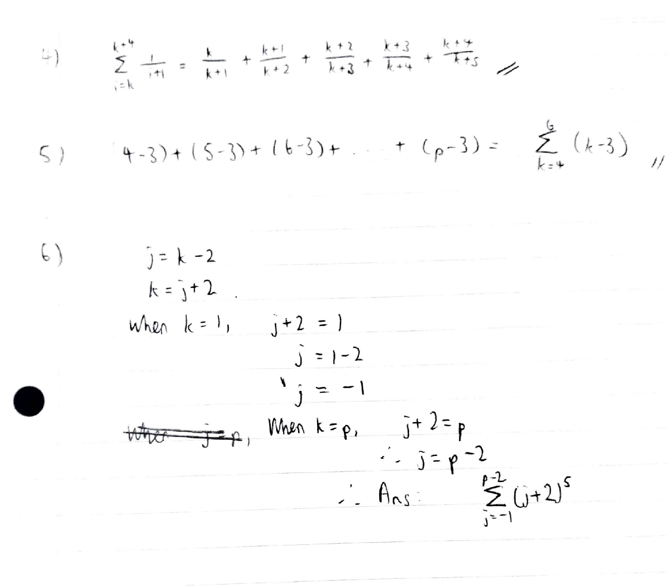

Answers
1.
2. a. a_{k} = 2^{k} b. a_{k} =

3. a. -21 b. -33
4.

5. Answers will be given in class.
6.

END

